# Technical Documentation

Slim Data Database System

Khalid Iyad Awad Al-Tarazi  
22036694

1. **System and User Requirements**

**User Requirements**

* The system should allow members to register by providing their information.
* The system should provide personalized workout plans based on each member's information.
* Members should be able to view their progress and receive recommendations.
* No member can register using the same email.
* The system should include all Equipment information to list the available equipment at the gym.
* The database system should include the information about each class for the members to access it.

**System Requirements**

* The system should have a backup mechanism to ensure the safety of the data.
* The system should require passwords for user authentication and access control.
* No booking or reservation for any class without specifying its schedule and duration.
* If the member did not fill the nationality, fill it with "Jordanian" by default.

1. **Entity Relationship Diagram**

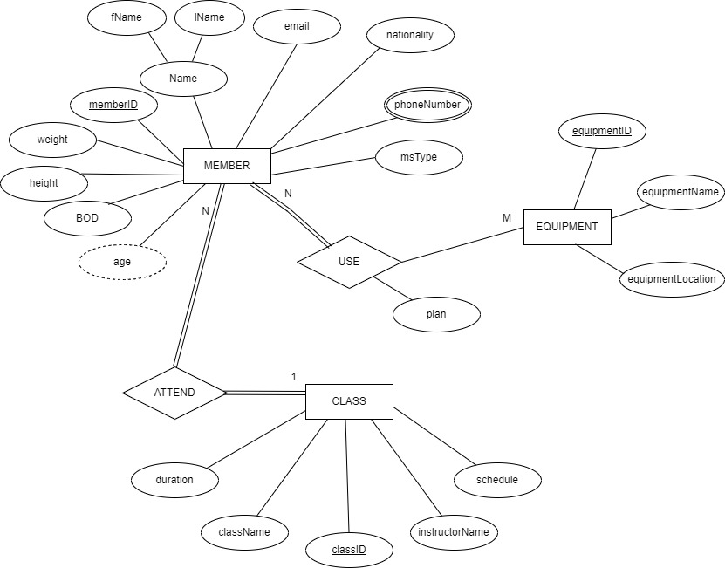

1. **Relational Schema**

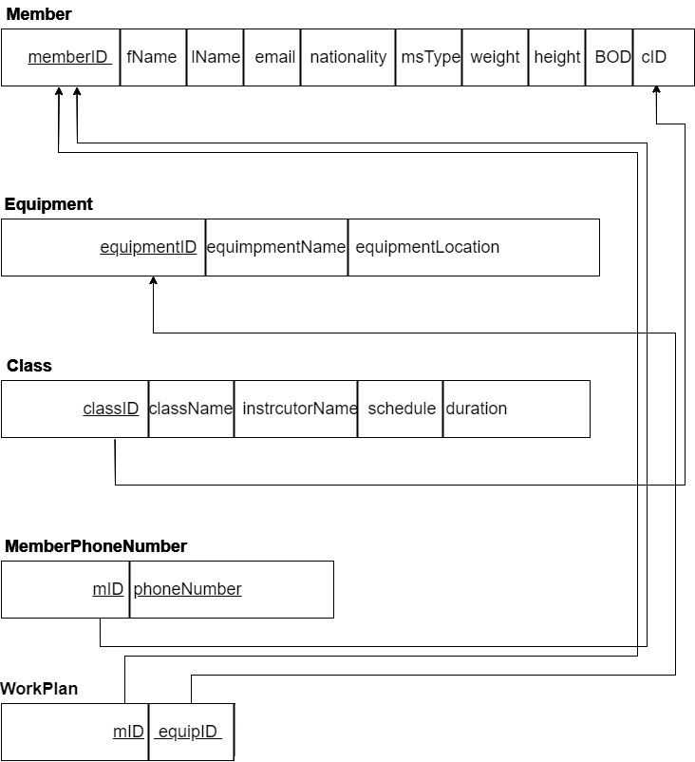

*Before Normalization*

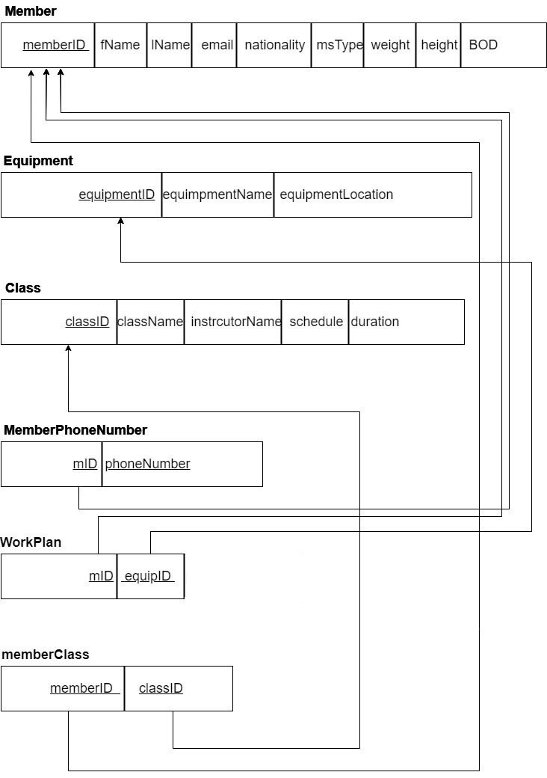

*After Normalization*

1. **Queries**

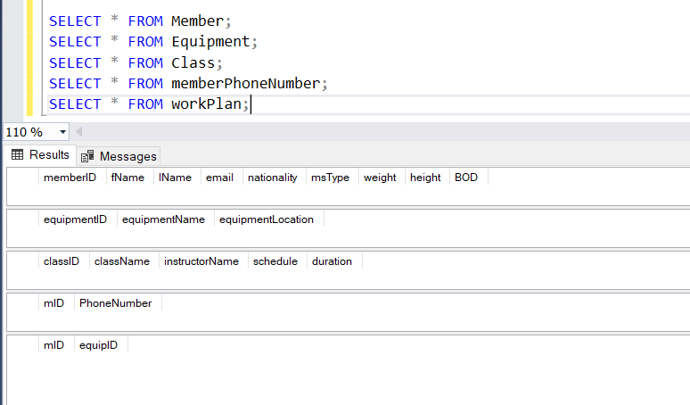

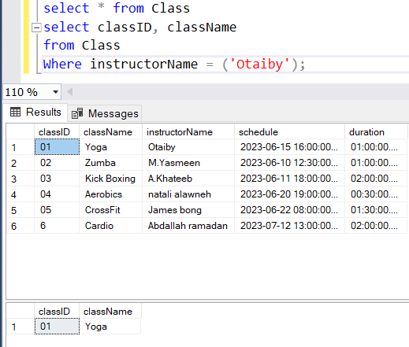

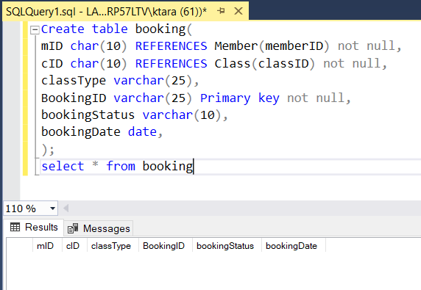

1. **Interface Design**

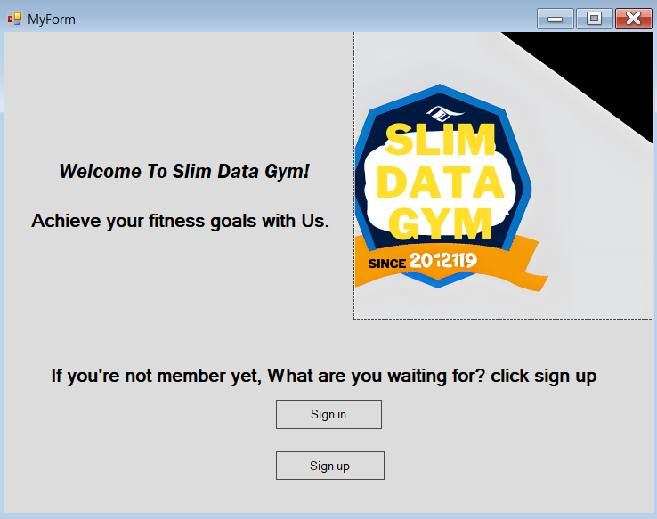

*Figure 1: Home Page. (sketches)*

*Figure 2: Sign up (Page 1).*

*Figure 3: Sign up (Page 2).*

*Figure 4: Member information page.*

*Figure 5: Class & Equipment page.*

*Figure 6: Booking page.*

*Figure 7: Registration page. (final)*

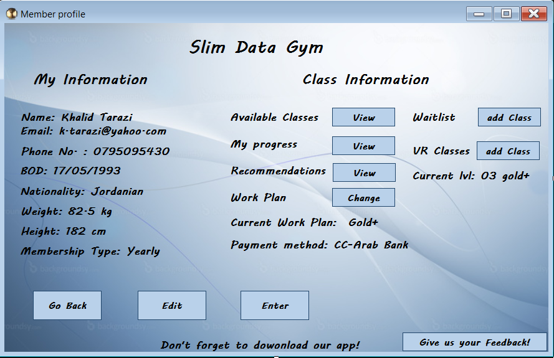

*Figure 8: Member page. (final)*

1. **Flowchart Diagram**

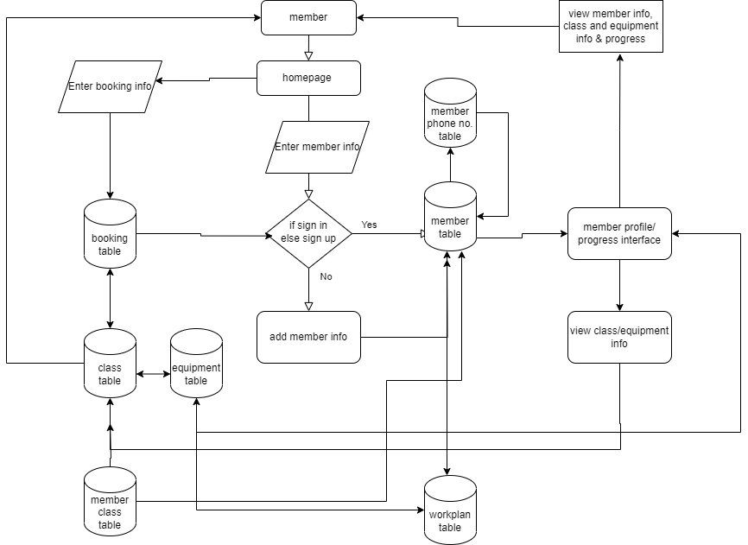

1. **Test Plans and Test Results**

**~ Test Plan for Slim Data Database System ~**

1. **Scope of the test:**

* Purpose: To validate that the slim data database system meets user and system requirements.
* Scope: Testing the functionality, data validation, and usability of the database system.
* Test Environment:

Hardware:

* Processor: Intel(R) Core (TM) i5-8265U CPU @ 1.60GHz, 1800 Mhz, 4 Core(s), 8 Logical Processor(s)
* RAM: 8GB
* Storage: 500GB

Software:

* Operating System: Microsoft Windows 10 Home
* SQL Server Management Studio Management Studio 19
* Microsoft Visual Studio 2022
* Software package: Slim Data Gym Database System.
* Version: 1.0
* Revision: 1

1. **Test Objectives:**

* Validate user & system requirements, such as member registration, class creation, email, and nationality validation.
* Verify Constraints, data validation, and default values.

1. **Test Approach:**

* Test Levels: Unit testing, integrity testing.
* Test Types: Functional testing, and data validation testing.
* Test Techniques: Black box.

1. **Test Scenarios and Test Cases:**

Test Case 1: Gym member registration.

* Description: Verify that a member can be successfully registered in the database.
* Test Steps:
  + Enter valid member information (memberID, fName, lName, email, BOD, nationality, phone no., weight, height, msType).
  + Click the "Insert" button.
* Expected Result: The member should be successfully registered in the database.

Test Case 2: Email validation.

* Description: Validate that the system checks for unique email addresses during member registration.
* Test Steps:
* 1. Enter email address that is already in the database.
* 2. Click the "insert" button.
* Expected Result:

The system should display an error message indicating that the email address is already registered in the database.

Test Case 3: Class creation.

* Description: Test the creation of a new class in the database.
* Test Steps:
* Enter valid class information (classID, className, instructorName, duration, schedule).
* Click the "Create Class" button.
* Expected Result: The class should be successfully created and stored in the database.

Test Case 4: Nationality default value.

* Description: Verify that the system assigns a default nationality value when the user does not provide one.
* Test Steps:
* Enter member information without providing the nationality.
* Click the "insert" button.
* Expected Result: The system should assign the default nationality value of "Jordanian" to the member.

1. **Test Execution and Reporting:**

* Execute the test cases according to the defined steps.
* Document the actual results and compare them to the expected results.
* Take screenshots of the test cases and their actual results and explain them.

|  |  |  |  |  |  |
| --- | --- | --- | --- | --- | --- |
| Case ID | Test scenario description | Test steps | Expected result | Actual result | Status |
| TC_SG_001 | Gym member registration  Verify that a member can be successfully registered in the database. | 1. Enter valid member information (memberID, fName, lName, email, BOD, nationality,phone no.,weight,height,msType).  2. Click the "Insert" button. | The member should be successfully registered in the database. | The member successfully registered in the database. | Pass |

|  |  |  |  |  |  |
| --- | --- | --- | --- | --- | --- |
| Case ID | Test scenario description | Test steps | Expected result | Actual result | Status |
| TC_SG_002 | Email validation.  Validate that the system checks for unique email addresses during member registration. | 1. Enter email address that is already in the database.  2. Click the "insert" button. | The system should display an error message indicating that the email address is already registered in the database. | The system displayed an error message indicating that the email address is already registered in the database and cannot be duplicated. | Pass |

|  |  |  |  |  |  |
| --- | --- | --- | --- | --- | --- |
| Case ID | Test scenario description | Test steps | Expected result | Actual result | Status |
| TC_SG_003 | Class creation.  Test the creation of a new class in the database. | 1.Enter valid class information (classID, className, instructorName, duration, schedule).  2.Click the "Execute" button. | The class should be successfully created and stored in the database. | The class successfully created and stored in the database. | Pass |

|  |  |  |  |  |  |
| --- | --- | --- | --- | --- | --- |
| Case ID | Test scenario description | Test steps | Expected result | Actual result | Status |
| TC_SG_004 | Nationality default value.  Verify that the system assigns a default nationality value when the user does not provide one. | 1.Enter member information without providing the nationality.  2.Click the "insert" button. | The system should assign the default nationality value of "Jordanian" to the member. | The system assigned the default nationality value of "Jordanian" to the new member. | Pass |